Press Release

Celebrate Ramadhan with Turkish Breakfasting at grandkemang Hotel Jakarta
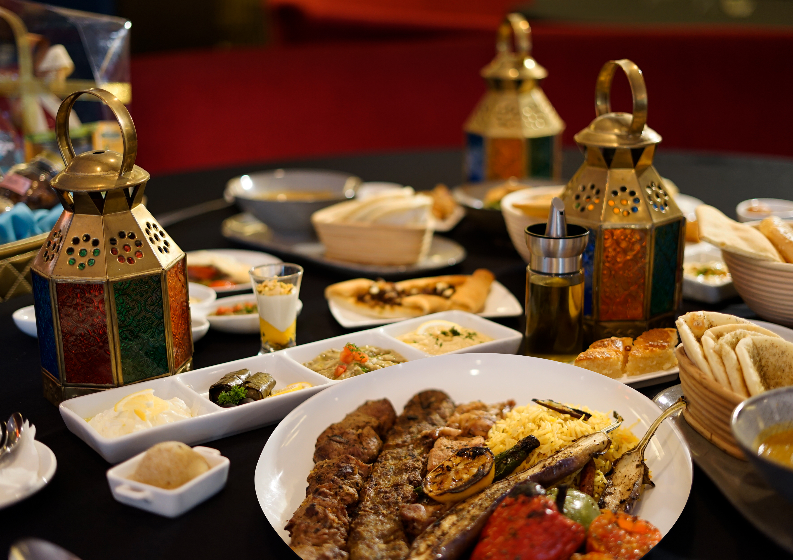
Jakarta, April 2019 – This year, Ramadan will fall in the beginning of May and will end in June. Grandkemang Hotel Jakarta is happily welcoming this holy month by fulfilling your holiday needs with amazing offerings throughout this spiritual time. From lavish breakfasting buffets to superior packages for meeting and stay during Ramadan & Idul Fitri.

Ramadan & Idul Fitri Room Package
Valid on 3 – 16 June 2019

Get new experiences during Ramadhan as grandkemang Hotel Jakarta will be happy to welcome you and your family with the special value-for-money stay package. Starting at IDR 820.000 nett/room you can stay in a fashionable deluxe room for a night including breakfast or Sahur for 2 (two) persons, or for IDR 920.000 nett/room in our cozy Grand Deluxe Room. Fantastic offers available:
- Includes free Tajil for those who purchase during Ramadhan
- Includes IDR 100.000,- dining voucher those who purchase during Lebaran

This package is a great option for you to celebrate Ramadhan with your family. The location of grandkemang Jakarta is in the heart of Kemang, right where the action is, near to Lippo Mall, across Kemchicks, and surrounded by entertainment spots, simply a great place to spend the holiday.

Iftar & Ta’jil Buffet
Open daily during Ramadan from 05.30 p.m. to 10.00 p.m. at Sperta restaurant

Break your fasting to satisfy your hunger and thirst with various buffet dishes at Sperta restaurant. Start with the selections of traditional fresh and sweet Ta’jil buffet from Indonesian and Asian traditional foods to western cuisine, such as dates, Kolak Pisang/Ubi, Bubur Kacang Hijau/ Bakwan Udang, Tempe Mendoan, Salads, Vegetable Spring Rolls, and many more. Fill your tummy afterwards with delicious main courses from local delights, Asian favourites, Middle Eastern, and Western cuisine made with the finest ingredients. Enjoy the Turkish cuisine made by our passionate chefs, such as Doner Kebab Station with chicken meat, beef or lamb completed with vegetables, Shish Kebab, Shish Taouk, Kofta Grill Vegetables, Rice Pillaf and many more. There will be also a Turkish themed dessert corner for those with a sweet tooth such as Assorted Turkish Sweets, a variety of Ice Creams, Hot Chocolate Pudding, Waffles, Kue Cubit and Pisang Goreng. All the lavish dishes from Ta’jil to dessert are charged at IDR 199.000++/person. If guests require the Special Ta’jil buffet at Sparca Lounge only, the charge is at IDR 85,000++/person.

There is a special freshening Turkish drink offered during Ramadhan that is called Ayran, ingredients contain of lemon, plain yoghurt, dried fruits and mint leaves. This Turkish drink leaves a refreshing sweet and sour taste with minty flavor in the end while you are breakfasting. Make sure to order one to our baristas at Sparca Lounge.

There is a special promo for those who are breakfasting with 10 pax, 1 person will get to breakfasting for free. For those who book for 20 pax will get a voucher of IDR 400.000 per booking.

Idul Fitri Hampers
Valid on 3 – 16 June, 2019 | D’Courtyard

Idul Fitri is a perfect moment to share happiness with your family, friends and colleagues by giving them a special gift. D’courtyard, grandkemang Hotel Jakarta presents exclusive hampers of appetizing homemade cookies containing: Nastar, Kaastangel and Putri Salju only for IDR 350.000++. Another hamper set offered are Bolu Tape sized 20x20cm with the selling price of IDR 250.000++ and Cake Pandan sized 20x20cm only for IDR 200.000++. For hampers order a 2-day advance booking is required. For those who like to serve cakes during Idul Fitri, there are sumptuous selections of cakes for your holiday treat at home or as a gift.

This year, grandkemang Jakarta presents a thoughtful unique gift of hampers called “Hampers of Paradise”, containing the 8 most favorite foods of Prophet Muhammad (SAW) including; Virgin Olive Oil, Pistachio, dried figs, Kurma Nabi, Arabic Mixed Nuts, Raisins, Yemen Honey and Zamzam Water. This perfect gift of the 8 items of Prophet Muhammad (SAW) favorite food, it only costs IDR 1.799.000,- net.

Halal Bi Halal Idul Fitri
3 – 16 June, 2019 | Sperta Restaurant

Celebrate the holy month with your family, friends and colleagues with grandkemang Hotel Jakarta. Only for IDR 300.000 nett/pax guests can get a complimentary meeting room including LCD projector and sound system with a complete buffet menu, with drinks for minimum booking of 100 people.

Grandkemang Hotel Jakarta has all that you need to spend the festivities of Ramadhan and Idul Fitri that will certainly make this holy month more meaningful.

For reservation and more information about this offer, please contact grandkemang Jakarta,
Jalan Kemang Raya no. 2H, Jakarta 12730,
Tel +62217194121 or email: resv@grandkemang.com

***
grandkemang Jakarta is a contemporary four star hotel and the preferred residence in Kemang, the heart of urban living in South Jakarta. Conveniently and strategically located in the hub of great shopping, dining and entertaining venues, the hotel is just minutes from Jakarta’s main business district.

-End-

For more information:
Yuanita Ayu Pratama
Marketing Communication Manager
grandkemang Jakarta 3rd Floor
Jl. Kemang Raya 2H, Kebayoran Baru, Jakarta 12730
Phone : +62 21 719 4121 ext 711
Email : mm@grandkemang.com
Website : www.grandkemang.com
Twitter & Instagram: @grandkemangJKT

Marissa Ariesta Sastradiredja
Marketing Communication Officer
grandkemang Jakarta 3rd Floor
Jl. Kemang Raya 2H, Kebayoran Baru, Jakarta 12730
Phone : +62 21 719 4121 ext 711
Email : pr@grandkemang.com
Website : www.grandkemang.com
Twitter & Instagram: @grandkemangJKT

