Press Release

Refreshing New Year with grandkemang Hotel Jakarta
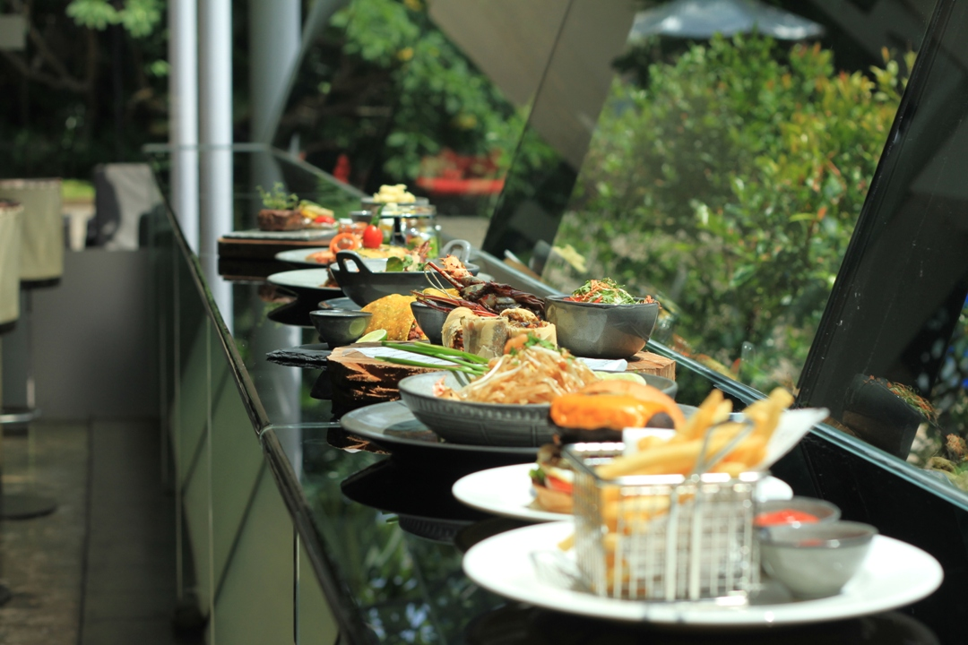
Jakarta, January 2019 – The hotel is welcoming this fresh new year with attractive promotions, exclusive in January only. Our guests get to spend their first month of the year with our culinary, bakery and beverages.

Borneo Lobster
One of the attractive promotions going on at grandkemang Jakarta for this month is the special delish Lobster menu available at Sperta Restaurant and Sparca Lounge. There are two types of lavish Lobster dish; Lobster Thermidor that is baked fresh Borneo Lobster, mixed garden greens that is only for IDR 450.000++, and Lobster Chili & Garlic, deep fried Borneo Lobster served with mantau, only for IDR 450.000++.
Start the year 2019 with these opulent lobster dishes with grandkemang Jakarta, as it is only available in January.

Lobster Delights
There are many ways you can enjoy a lobster dish. We are serving two kinds of Lobster Delights that you may consume while chit chatting with your companions. This month, we offer Lobster and Avocado Rolls, topped with tobiko, served with brioche bun, fries, and garden greens only for IDR 150.000++. We also offer Jumbo Lobster Lumpia with Thai chili dip and Asian slaw, only for IDR 150.000++.

Seafood Night
This year, we are excited to announce that we are launching a Seafood Night starting January for our guests to enjoy their Saturday Night with their family, partner or peers, available from 6 PM to 10 PM, only for IDR 325.000++. The all-you-can-eat buffet dishes provided are appetizers, seafood on ice, soup station, barbeque station, sushi and sashimi station, Asian to Western dishes, pizza corner and desserts. If you wish to order our fresh Borneo Lobster for BBQ, there will be additional IDR 400.000 nett per pieces.
Children who are below 110cm gets to dine for FREE! Children who are above 110cm and below 140cm gets 50% discount off.

Sunday Brunch
The weekend is best spent with family. grandkemang Jakarta has some great options that you and your family will love. Besides our Seafood Night, one of the weekend itinerary you must try is our ‘Brunch it Up’. It is a Sunday Brunch dedicated for the families and friends available from 12 PM until 3 PM.
For only IDR 325.000++ per pax, you can savor the unlimited buffet spread full of delicious cuisines. Finest ingredients ranging from European specialties with a spread of Asian cuisine, Western Carving Station, Italian Pasta Corner, Dim Sum Station, Sushi Sashimi Corner, Indonesian favourites, wide selections of the best French bread and cheese, dessert and pastries, and complemented with beverage station in every week. The ‘talk of the town’ will be the Raclette Cheese Corner complemented with Parma Ham selections.
Children who are below 110cm gets to dine for FREE! Children who are above 110cm and below 140cm gets 50% discount off.

Happy Hour
Swing by to Sparca Lounge with your buddies as we offer Happy Hour daily, from 5 PM to 8 PM. We also offer our Bali Hai promotion, only for IDR 66.000 nett per bottle during Happy Hour. Purchase a bucket of beer that consists of 5 beers with fries, only for IDR 250.000 nett.

Yum-Yum Cassava & Pandan Latte
Another attractive promotions going on at D’Courtyard, with this month’s edition ‘Yum-Yum Cassava’ exclusive only in January. You may try our Cassava Cheese cake, only for IDR 350.000++ for whole cake (20x20cm) or IDR 35.000++ per slice, Cassava Tart available for IDR 300.000 for whole cake (20x20cm) or IDR 30.000++ per slice or our Cassava Fruit Tart for IDR 300.000++ for whole cake (20x20cm) or IDR 30.000++ per slice.
We also offer a unique beverage menu special January edition, ‘Original Pandan Latte’ available both Hot or Iced, only for IDR 50.000 nett.

For reservation and more information about this offer, please contact grandkemang Jakarta,
Jalan Kemang Raya no. 2H, Jakarta 12730,
Tel +62217194121 or email: info@grandkemang.com
Visit us www.grandkemang.com
***
grandkemang Jakarta is a contemporary hotel and the preferred residence in Kemang, the heart of urban living in South Jakarta. Conveniently and strategically located in the hub of great shopping, dining and entertaining venues, the hotel is just minutes from Jakarta’s main business district. The hotel offers 203 guest rooms and residence suites for both travellers and long stay guests, complete with newly renovated luxurious facilities, featuring International standards of comfort and convenience.

- End –

For more information:
Yuanita Ayu Pratama
Marketing Communication Manager
grandkemang Jakarta 3rd Floor
Jl. Kemang Raya 2H, Kebayoran Baru, Jakarta 12730
Phone : +62 21 719 4121 ext 716
Email : mm@grandkemang.com
Website : www.grandkemang.com
Facebook, Twitter & Instagram: @grandkemangJKT

Marissa Ariesta Sastradiredja
Marketing Communication Officer
grandkemang Jakarta 3rd Floor
Jl. Kemang Raya 2H, Kebayoran Baru, Jakarta 12730
Phone : +62 21 719 4121 ext 719
Email : pr@grandkemang.com
Website : www.grandkemang.com
Facebook, Twitter & Instagram: @grandkemangJKT

