Press Release

Tropical Madness at grandkemang Hotel Jakarta
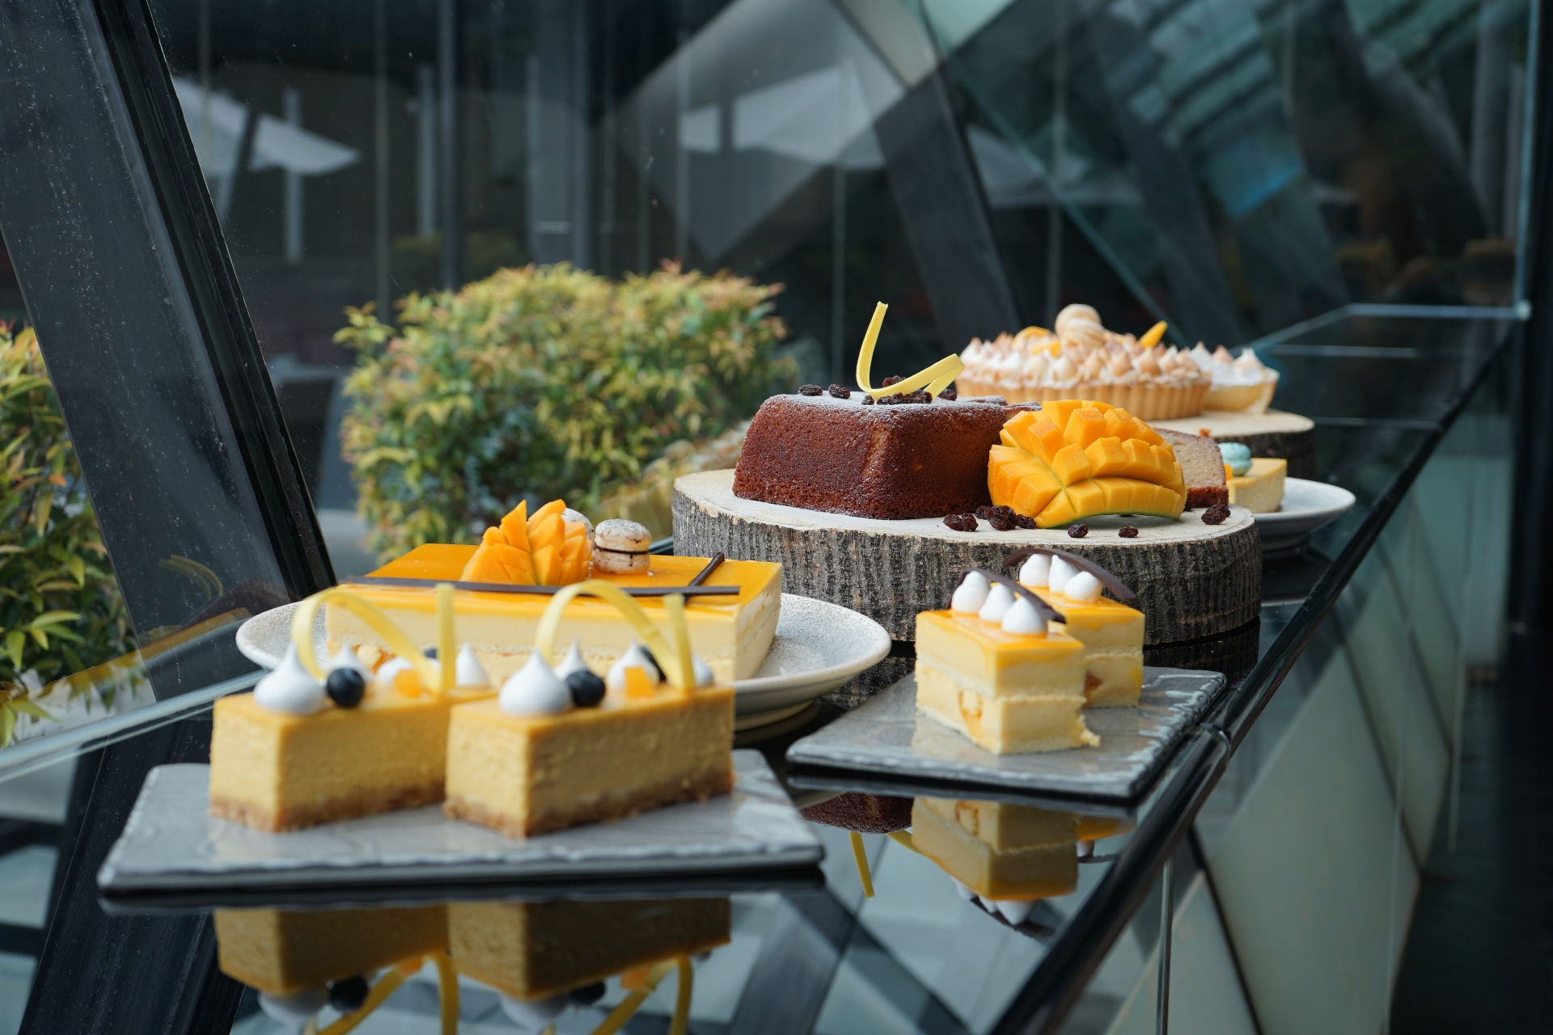
Jakarta, March 2019 – On the third month of the year, grandkemang Jakarta offers various of attractive promotions on our food & beverages and rooms exclusive in March only.

Crack – Crack Crab
Make sure you try our limited edition “Crack – Crack Crab” available in March only at Sperta Restaurant. There are 3 kinds of freshly cooked crabs that you must taste: Salt & Pepper Crab, a 350gr Mud Crab that is prepared with freshly cracked white pepper, garlic, rice wine and chili served with steamed rice for only IDR 195.000++ per portion. The second dish is Singaporean Chili Crab, a 350gr Mud Crab, Singaporean style stir fried with garlic and tomato-chili based, served with steamed plain mantao, that has a balanced taste of spicy yet sweet sauce completed with the plain mantao, for only IDR 195.000++ per portion. Lastly, Black Pepper Crab, a 350gr Mud Crab with Singaporean styled boiled crab in rich black pepper sauce, served with fresh French baguette. To maximize your experience with Black Pepper Crab, you may try to dip the baguette to the black pepper sauce. This lavish dish is only for IDR 195.000++ per portion.

Yummy Crab Bites
Chill with your friends at our hotel restaurant and lounge while munching on the limited offer of our crab snacks, exclusive this month only. Have a bite of our Crab Rangoon, deep fried filled crisp wonton with cream cheese and crab meat, served with sweet and sour sauce for only IDR 65.000++ per portion. Or try out our Crisp California Roll Crab Tacos, a mini tacos of crab meat, avocado, cucumber, nori, Black Jack Cheese served with wasabi mayo for only IDR 75.000++ per portion.

Mango Madness
This month is very exciting for the mango lovers, because grandkemang Jakarta offers freshly baked mango cakes at D’Courtyard, exclusive March offer only. There is Mango Cheese Cake, for only IDR 350.000++ per 20x20 cm and IDR 35.000++ per slice. The mixture of cheese and mango melt well in your mouth that keeps you wanting for more. We also offer Mango Mousse Cake for only IDR 300.000++ per 20x20 cm and IDR 35.000++ per slice. You will definitely like this cake for its creamy soft texture in your mouth with the sweetness of mango. You shouldn’t miss our Mango Meringue Tart for only IDR 300.000++ per 20x20cm and IDR 35.000++ per slice, the softness of the cake that melts in your mouth will surely satisfy you. You may try our Mango Bread Loaf freshly baked from our oven, for only IDR 100.000++ and our Hongkong Style Mango Pudding served in a cup, for only IDR 50.000++.
All of our cakes and pastries are 50% off after 6 PM.

Buy One Get One Stay
The long weekend is what everyone awaits. There is an attractive offer starting from 7th until 10th March 2019, for only IDR 1.400.000 nett. Guest may chose either:
- Purchase one night get free the other night
- Purchase one room get free another room
You may book it through our receptionist via call, walk-in or from our website. The rooms for this promotion is only valid for Deluxe and Grand Deluxe Rooms with complimentary daily buffet breakfast and Wi-Fi.

March Birthday Celebration
This month is the lucky month of March babies. To celebrate their birthday, grandkemang Jakarta offers a free buffet lunch or dinner for the birthday person at Sperta Restaurant, as long as they bring a paying guest with them and show their ID card to our staffs as a proof of their birth month. This offer is valid for the whole month, from 1st until 31st of March 2019.

For reservation and more information about this offer, please contact grandkemang Jakarta,
Jalan Kemang Raya no. 2H, Jakarta 12730,
Tel +62217194121, email: info@grandkemang.com or WhatsApp: +628111314121
Visit us www.grandkemang.com
***
grandkemang Jakarta is a contemporary hotel and the preferred residence in Kemang, the heart of urban living in South Jakarta. Conveniently and strategically located in the hub of great shopping, dining and entertaining venues, the hotel is just minutes from Jakarta’s main business district. The hotel offers 203 guest rooms and residence suites for both travellers and long stay guests, complete with newly renovated luxurious facilities, featuring International standards of comfort and convenience.

- End –

For more information:
Yuanita Ayu Pratama
Marketing Communication Manager
grandkemang Jakarta 3rd Floor
Jl. Kemang Raya 2H, Kebayoran Baru, Jakarta 12730
Phone : +62 21 719 4121 ext 716
Email : mm@grandkemang.com
Website : www.grandkemang.com
Facebook, Twitter & Instagram: @grandkemangJKT

Marissa Ariesta Sastradiredja
Marketing Communication Officer
grandkemang Jakarta 3rd Floor
Jl. Kemang Raya 2H, Kebayoran Baru, Jakarta 12730
Phone : +62 21 719 4121 ext 719
Email : pr@grandkemang.com
Website : www.grandkemang.com
Facebook, Twitter & Instagram: @grandkemangJKT

